1

import java.util.\*;

class p1{

public static void main(String args[]){

Scanner sc=new Scanner(System.in);

int t=sc.nextInt();

int i;

for(i=1;i<=t;i++){

try{

long n=sc.nextLong();

System.out.println(n + " can be fitted in:");

if (n >= -128 && n <= 127) {

System.out.println("\* byte");

}

if (n >= -32768 && n <= 32767) {

System.out.println("\* short");

}

if (n >= -2147483648L && n <= 2147483647L) {

System.out.println("\* int");

}

if (n >= -9223372036854775808L && n <= 9223372036854775807L) {

System.out.println("\* long");

}

}

catch (Exception e) {

System.out.println(sc.nextLong()+ " can't be fitted anywhere.");

}

System.out.println();

}

}

}

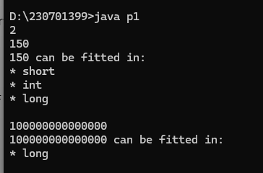

2

import java.util.\*;

class p2{

public static void main(String arg[]){

Scanner sc=new Scanner(System.in);

int s=sc.nextInt();

double s1=s/100.0;

System.out.println(String.format("%.2f",s1));

}

}

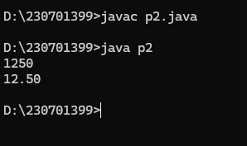

3

import java.util.\*;

class p3{

public static void main(String arg[]){

Scanner sc=new Scanner(System.in);

double s=sc.nextDouble();

int s1=(int)s;

System.out.println(s1);

}

}

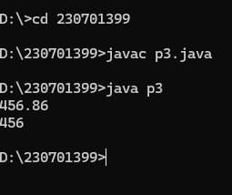

4

import java.util.\*;

class p4{

public static void main(String arg[]){

Scanner sc=new Scanner(System.in);

int sal=sc.nextInt();

double p=sc.nextDouble();

double s1=(sal\*(p/100))+sal;

System.out.println(String.format("%.1f",s1));

}

}

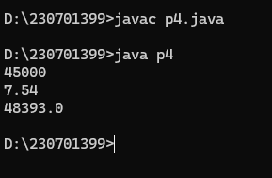

5

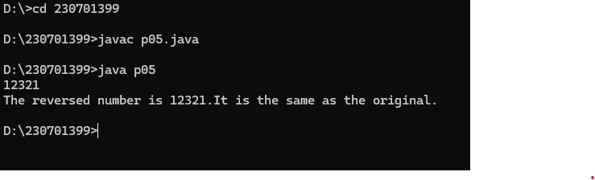

import java.util.\*;

class p5{

public static void main(String arg[]){

Scanner sc=new Scanner(System.in);

int n1=sc.nextInt();

int rem,rev=0;

int n=n1;

while(n!=0){

rem=n%10;

rev=(rev\*10)+rem;

n=n/10;

}

if(n1==rev){

System.out.println(String.format("The reversed number is "+n1+"."+"It is the same as the original."));

}

else{

System.out.println(String.format("The reversed number is"+n1+"."+"It is not the same as the original."));

}

}

}

6

import java.util.\*;

class p6{

public static void main(String args[]){

Scanner sc=new Scanner(System.in);

int n=sc.nextInt();

int i;

int j;

for(i=1;i<=n;i++){

for(j=n;j>i;j--){

System.out.print(" ");

}

for(j=i;j>=1;j--){

System.out.print("\*");

}

for(j=2;j<=i;j++){

System.out.print("\*");

}

System.out.println();

}

for(i=n-1;i>=1;i--){

for(j=n;j>i;j--){

System.out.print(" ");

}

for(j=i;j>=1;j--){

System.out.print("\*");

}

for(j=2;j<=i;j++){

System.out.print("\*");

}

System.out.println();

}

}

}

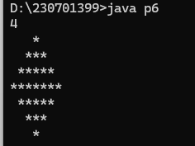

7

import java.util.\*;

public class p7{

public static void main(String[] args) {

Scanner scanner = new Scanner(System.in);

System.out.print("Enter the value of n: ");

int n = scanner.nextInt();

for (int i = 0; i < n; i++) {

for (int j = 0; j < n - i - 1; j++) {

System.out.print(" ");

}

int val = 1;

for (int j = 0; j <= i; j++) {

System.out.print(val + " ");

val = val \* (i - j) / (j + 1);

}

System.out.println();

}

for (int i = n - 2; i >= 0; i--) {

for (int j = 0; j < n - i - 1; j++) {

System.out.print(" ");

}

int val = 1;

for (int j = 0; j <= i; j++) {

System.out.print(val + " ");

val = val \* (i - j) / (j + 1);

}

System.out.println();

}

}

}

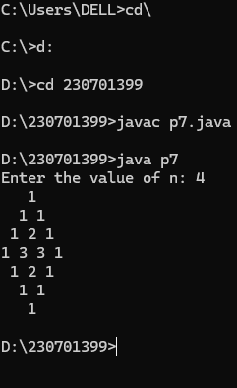

8

import java.util.\*;

class p8 {

public static void main(String[] args) {

Scanner sc = new Scanner(System.in);

int q = sc.nextInt();

for (int i = 0; i < q; i++) {

int a = sc.nextInt();

int b = sc.nextInt();

int n = sc.nextInt();

int sum = a;

for (int j = 0; j < n; j++){

sum += (int)(Math.pow(2, j) \* b);

System.out.print(sum + " ");

}

}

}

}

